Install Jenkins on Amazon Linux 2 instance:
Step-1: Launch the basic EC2 instance with 8080 port enable in the security group.
Step-2: Update the software package of the instance using the below command:
sudo yum update -y
Step-3: Install java packages and remove the oldest version of java if any:
sudo yum install java-1.8.0
sudo yum remove java-1.7.0-openjdk
Step-4: Add the Jenkins repo:
sudo wget -O /etc/yum.repos.d/jenkins.repo http://pkg.jenkins-ci.org/redhat/jenkins.repo
Step-5: Import the key file:
Note: Below is the2 hyphens attached to the import keyword.
sudo rpm --import https://pkg.jenkins.io/redhat/jenkins.io.key
yum clean all
yum repolist all
Step-6: Install Jenkins using the below command:
sudo yum install jenkins -y
Step-7: Start the Jenkins service:
sudo service jenkins start
Step-8: Open the browser and hit the public IP along with the 8080 port.
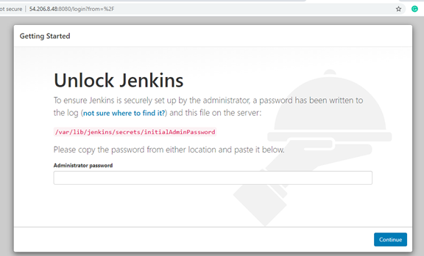
Step-9: Copy the path and get the password from the server:
sudo cat /var/lib/jenkins/secrets/initialAdminPassword
Step-10: Install the suggested plugins :
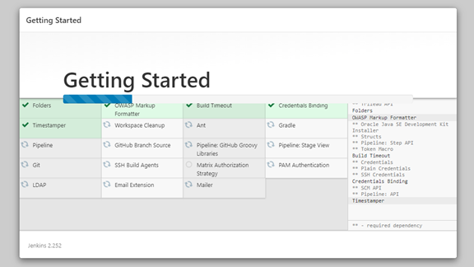
Step-11: Add the user credentials and save it:
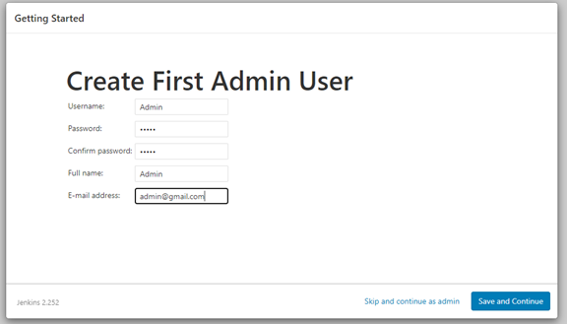
Step-12: Installation and configuration are completed and now you can start creating the Jenkins jobs.
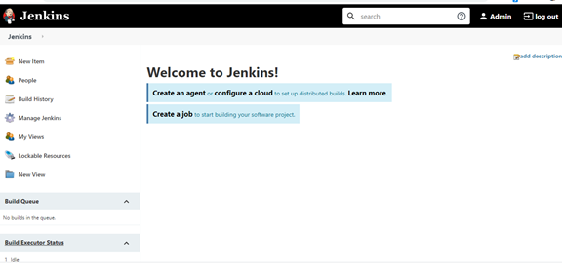
Thank you.

70
5

https://medium.com/@kalyanshettynetra/install-jenkins-on-amazon-linux-2-instance-52105b5bc7e1

https://linuxize.com/post/how-to-install-jenkins-on-centos-7/

https://phoenixnap.com/kb/how-to-install-jenkins-on-centos-8
https://www.jenkins.io/doc/book/installing/linux/
https://www.digitalocean.com/community/tutorials/how-to-install-jenkins-on-ubuntu-18-04
https://www.theserverside.com/blog/Coffee-Talk-Java-News-Stories-and-Opinions/jenkins-ubuntu-20-install-git-jdk-java-ci-cd

